M. Sai Harshitha
192424408
CSA0701
SET- 7: Customer Demographics Analysis
1. Procedure to Create a Bar Graph
- Open Tableau and connect to the Customer Demographics dataset.
- Open a new worksheet.
- Drag Age to the Columns shelf.
- Drag Customer ID to the Rows shelf.
- Change the Marks type to Bar.
- Rename the chart title as "Distribution of Customer Ages".
- Rename the axes:
- X-axis: Age
- Y-axis: Customer Count
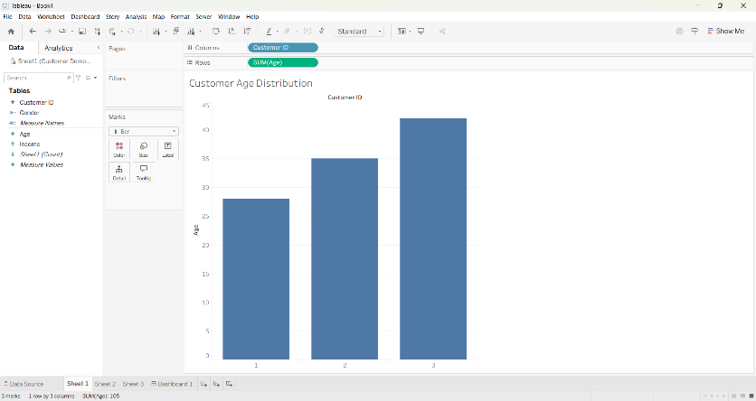

2. Procedure to Create a Pie Chart
- Open a new worksheet.
- Change the Marks type to Pie.
- Drag Gender to the Color shelf.
- Drag Customer ID to the Angle shelf.
- Drag Customer ID again to the Label shelf.
- Right-click Customer ID on the Marks card and select Measure → Count.
- Edit the chart title as "Distribution of Customers by Gender".
- Enable Show Mark Labels from the Label option.
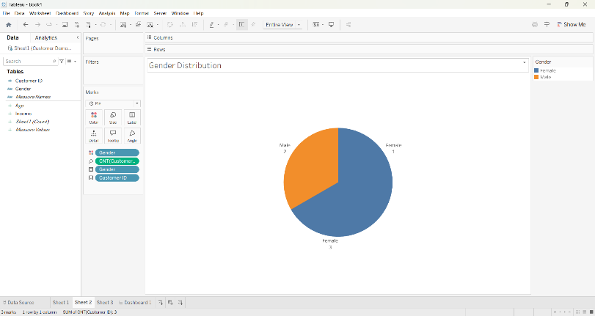

3. Procedure to Create a Table
- Open a new worksheet.
- Drag Customer ID to the Rows shelf.
- Drag the following fields to the Text option on the Marks card:
Age
Gender
Income
- Alternatively, place Measure Names on Columns and the required fields on Text to display them in tabular format.
- Rename the worksheet title as "Customer Demographics Table".
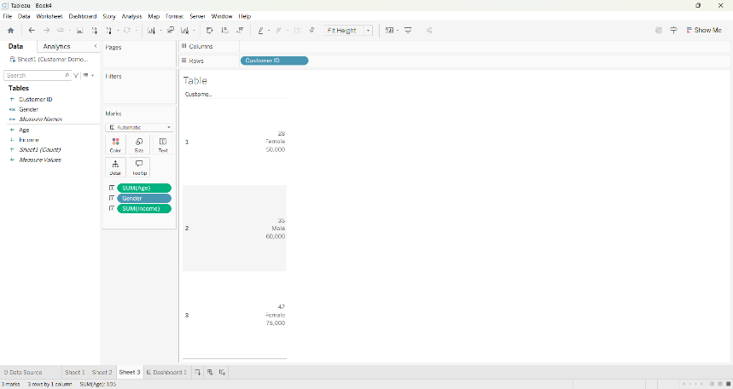
4. Procedure to Create a Dash Board
1.Click the New Dashboard icon.
2.Set the dashboard size to Automatic.
3.Drag the following worksheets onto the dashboard:
Bar Chart
Pie Chart
4.Demographics Table
5.Arrange all worksheets appropriately.
6.Enable interactive filtering using Dashboard → Actions (optional)
7. Rename the dashboard as "Customer Demographics Dashboard".
